Data cleaning using Tableau Prep
Description: This assignment provides the opportunity to practice basic data cleaning using Tableau Prep. You will be working with a dataset that was collected through web scraping for data scientist jobs. Please answer the following question.
- What is the data type of each column? Please categorize them using the TNOIRT schema we mentioned in class. (Answer input to this document is needed for this question)
Colum | ID | Job Title | Salary Estimate | Job Description | Rating | Company Name | Location | Headquarters
Type
Colum | Size | Founded | Type of ownership | Industry | Sector | Revenue | Competitors | /
Type |  |  |  |  |  |  |  | /

- Create a new clean step named “drop duplicates” for data cleaning. There are duplicated records in the dataset (ID identifies each unique response). Please remove the duplicates. How many unique records are left?

- Create a new clean step named “clean salary”. Salary Estimate column has the salary level for each response. Most of the values (not all) are expressed with a redundant suffix “(Glassdoor est.)”. Please create a new column “Salary” that unifies them without the suffix. Describe your operations with screenshot(s).

- Create a new clean step named “trim”. Values in some columns that have white space before, or after the value. Please remove the extra space with cells of each TEXT field. Describe your operations with screenshot(s).

- Create a new clean step named “filter rating”. For Rating, some values are 0, while others left the value empty in order to indicate no ratings available. These ratings are invalid. Please filter all rows with empty ratings (null) and keep rows with non-empty ratings. How many rows are left? Describe your operations with screenshot(s).

- Create a new clean step named “fix data type”. Examine the column "Founded". It is currently assigned to a String data type (indicated by “Abc”). Please convert it to the date data type. Describe your operations with screenshot(s).

- Create a new clean step named “split location”. The Location column collects the city information for each response. However, they put the state name with the city names. We can see that city name and state name seem to be separated by a comma. Please split the column by comma and name the two split columns “city” and “state”. Describe your operations with screenshot(s).

- Your data is looking good as follows and you're ready to generate your output file.
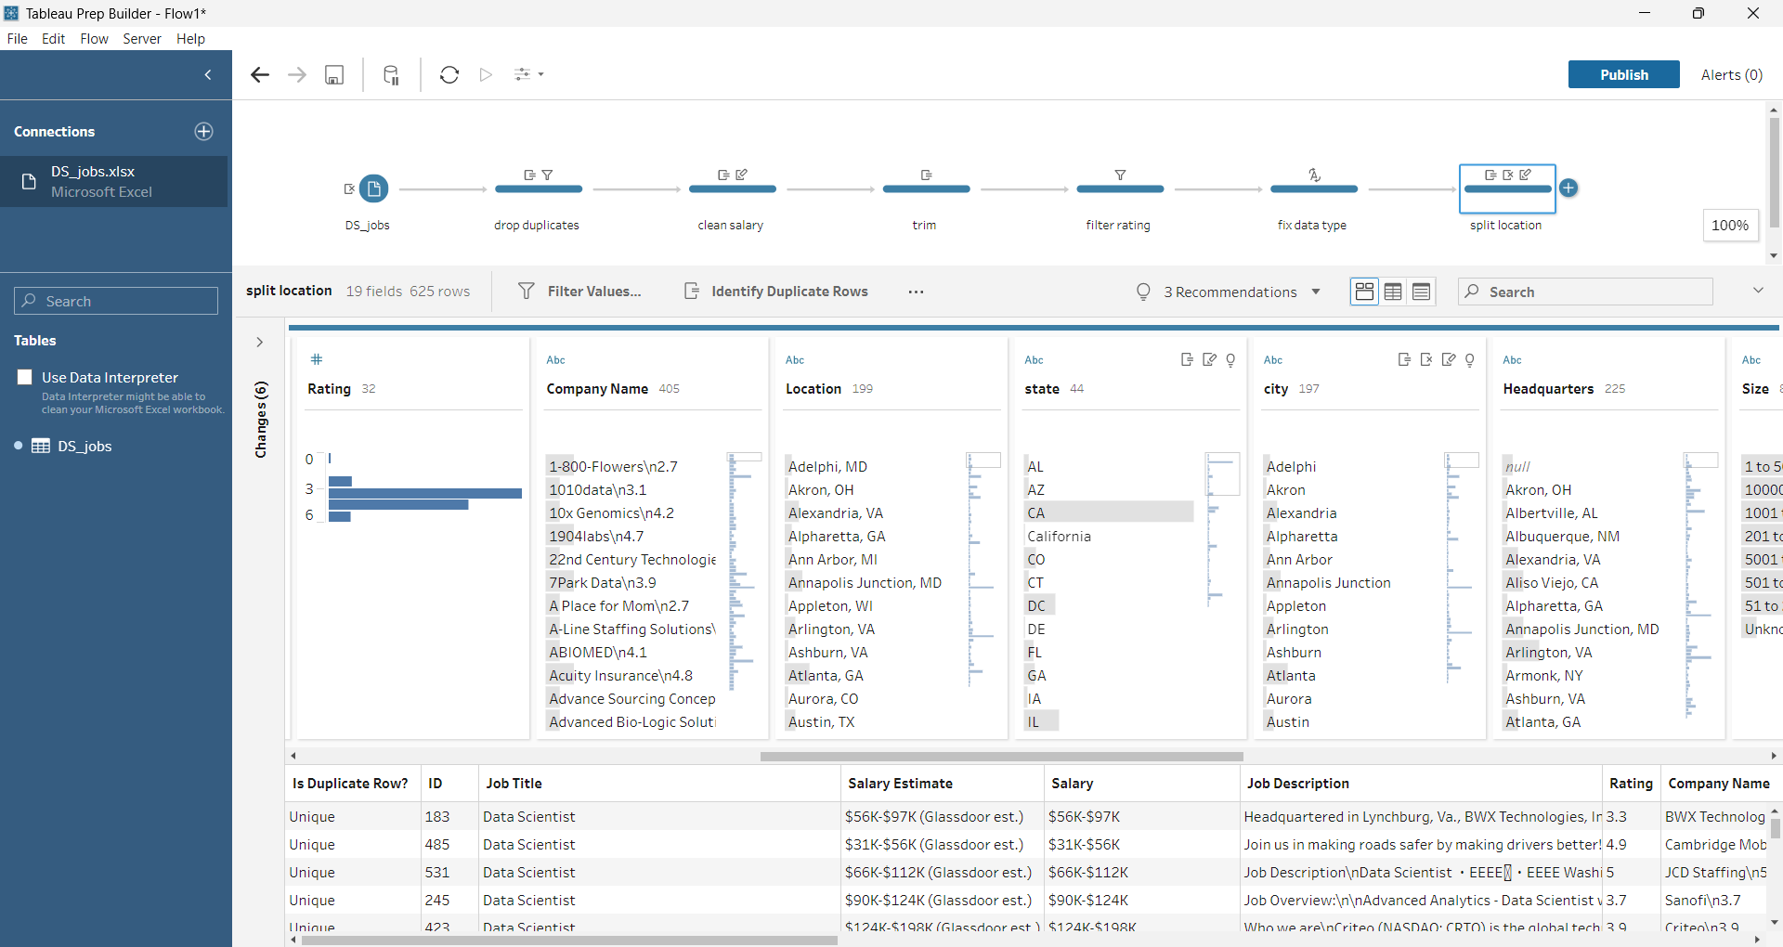
Create a new output step named “split location”. Save your processed data as an Excel file and name it Output.xlsx. You may use any worksheet name.
Save your Tableau Flow (File -> Save) as Flow1.tfl. You are ready to submit the processed data and Tableau flow!

